To Run:

    Unzip the project submittal folder into a specified folder on your desktop or some directory. Once the files have unzipped open .jar file and the program should load correctly.

\*\*Note: I was having trouble with combining both the color code and intensity matrix into the 89 value x 100 value array. For some reason the 26th index on all photos is obscured by 10 -2 to 10-5 within the standard deviation and mean.

To Use:

    You can navigate the entries in the image database using the previous and next pages. Clicking one of the photograph icons in the bottom panel will display their full picture to the left of the buttons. With an image selected, you can alter the order of the images in the database by selecting either color code, intensity, or intensity/color code buttons. If there is relevance feedback that you would like to process, you must click the relevance check box. This enables relevance checkboxes for all images in the database. After selecting a few images that match your search criteria, you then can click the intensity/color code button and the images will reorder in the database. The reset button resets the GUI to it's starting form, and resets all values obtained from prior manipulations.

Screen Dumps:

query image 1.jpg

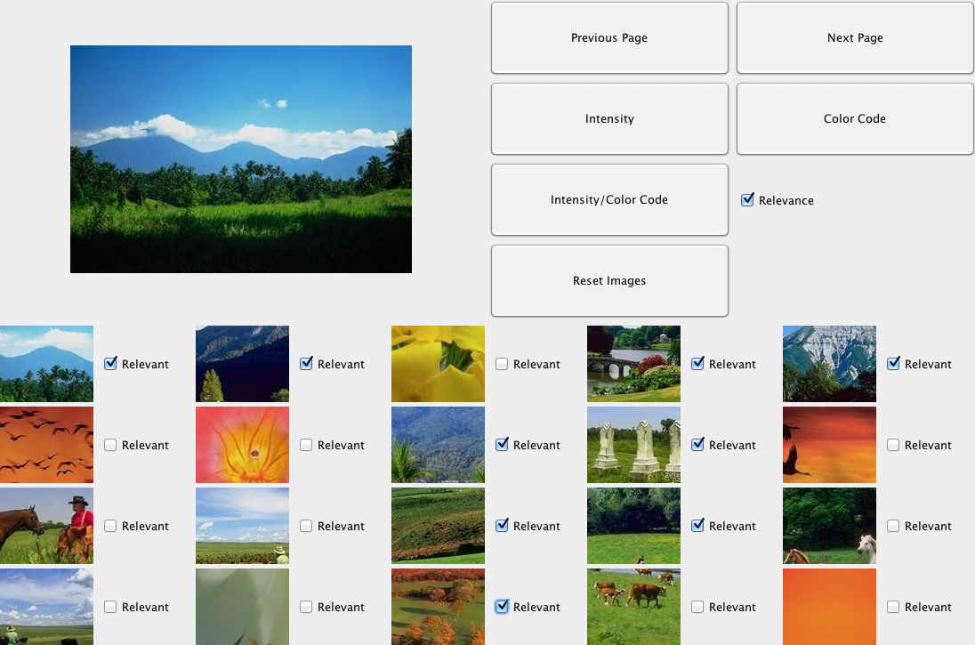

first iteration

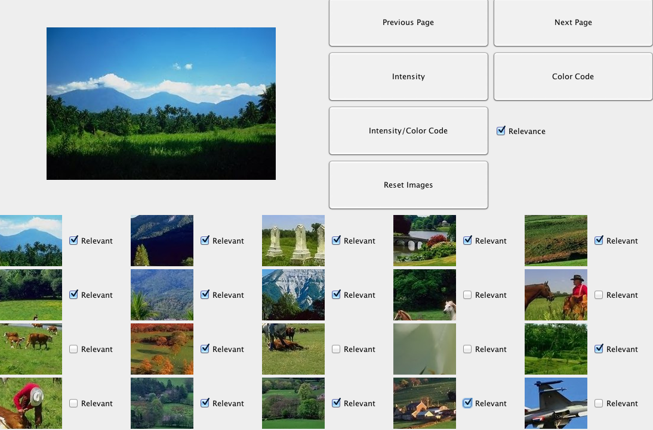

Second iteration

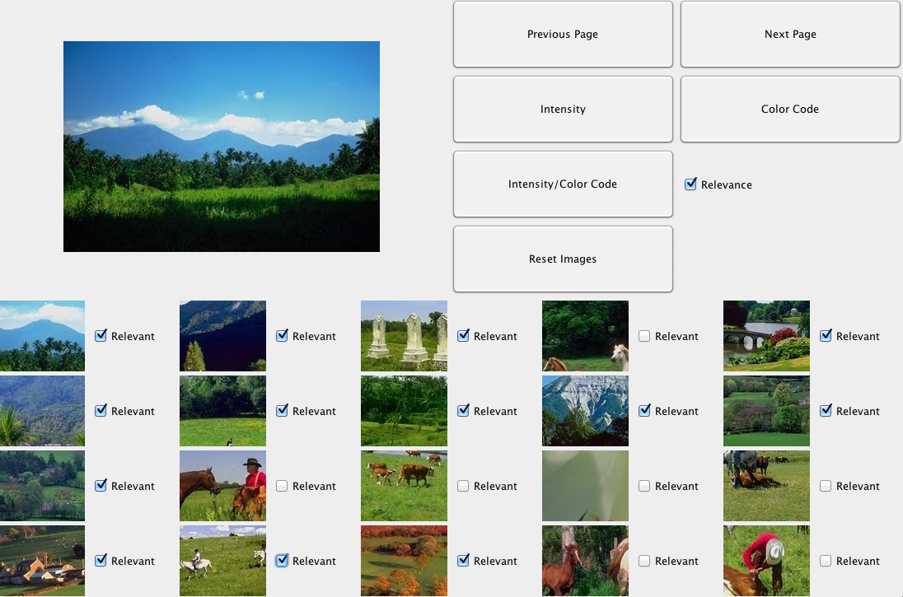

Third iteration

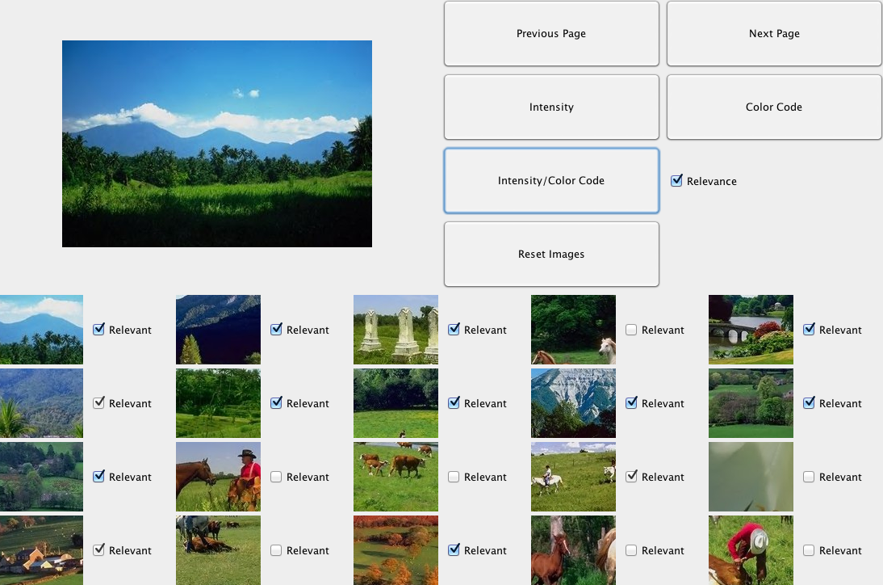

precision values

I don’t precisely know what these are…